TRANSIT GATEWAY

# Create three VPC’S

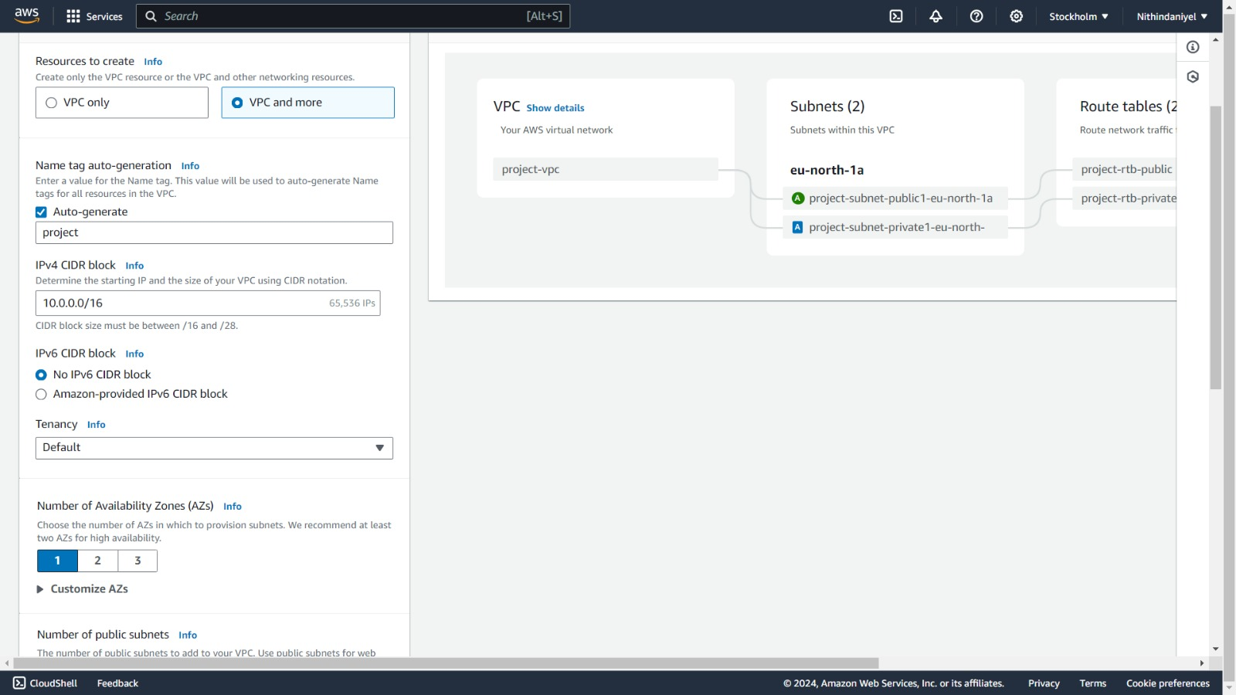

# *Create vpc in vpc and more

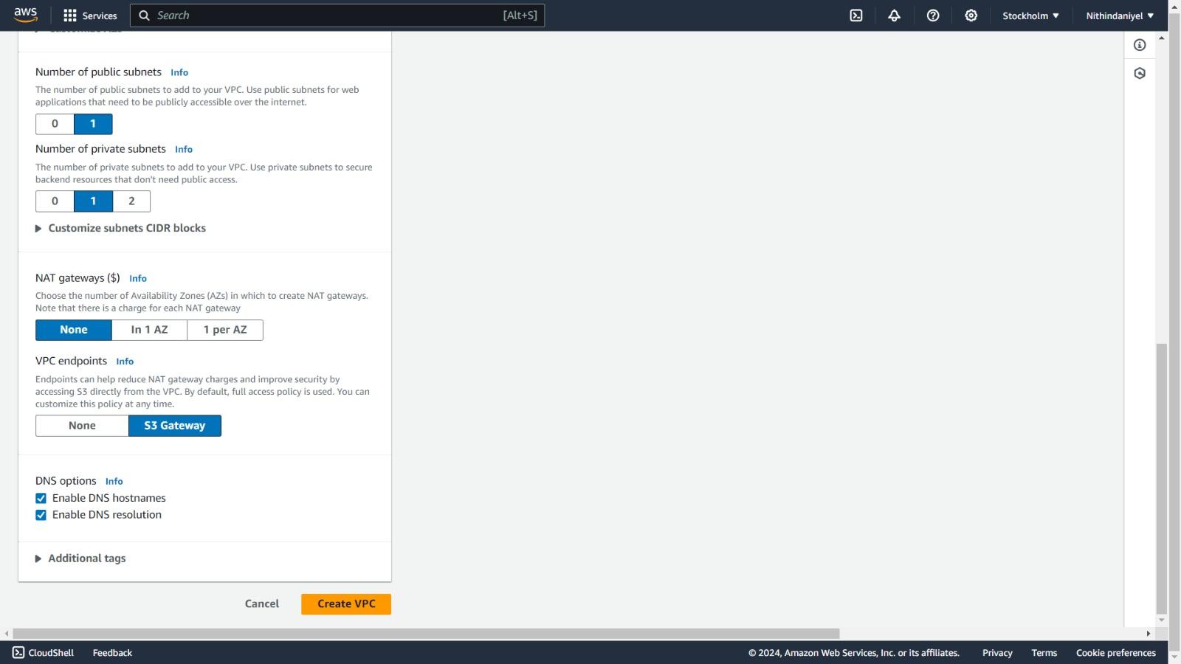

## CREATE TRANSIT GATEWAY

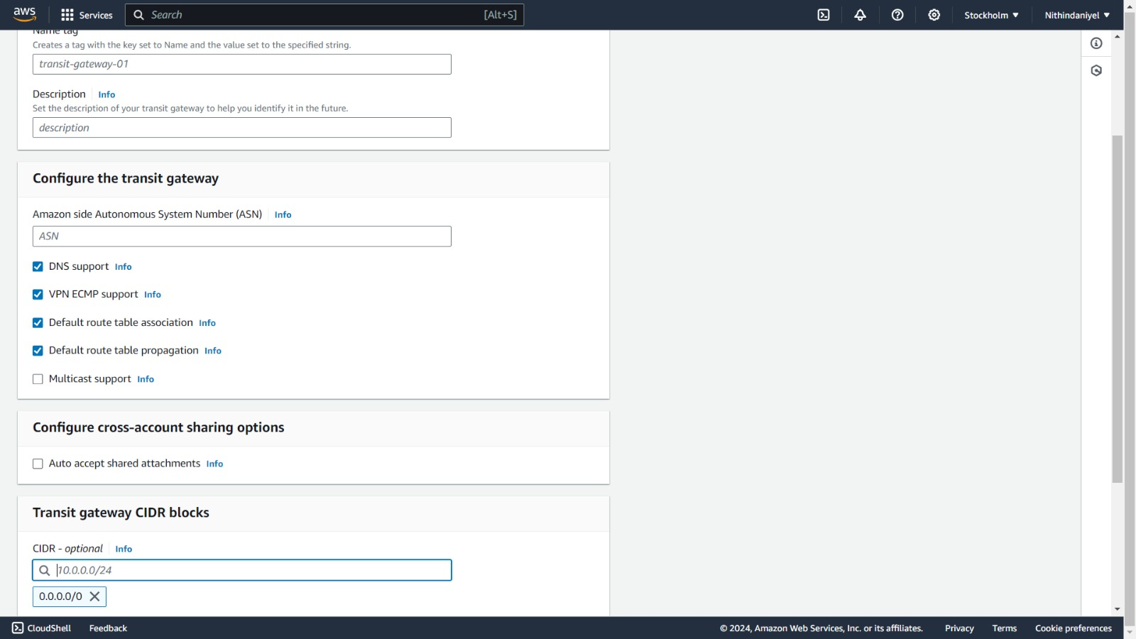

# *Create transit gateway attachment

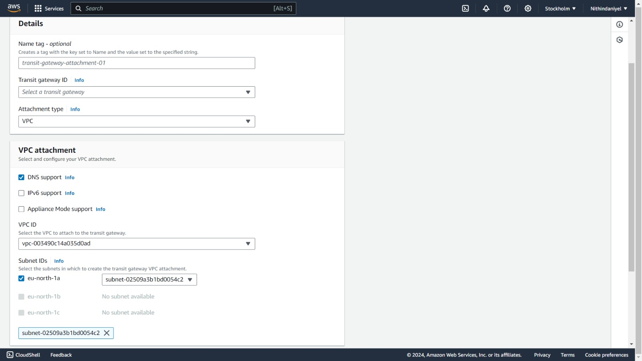

# *connect the three vpc’s with three attachments

# *connect with public subnet

*Create 3 instances for 3 VPC’s.

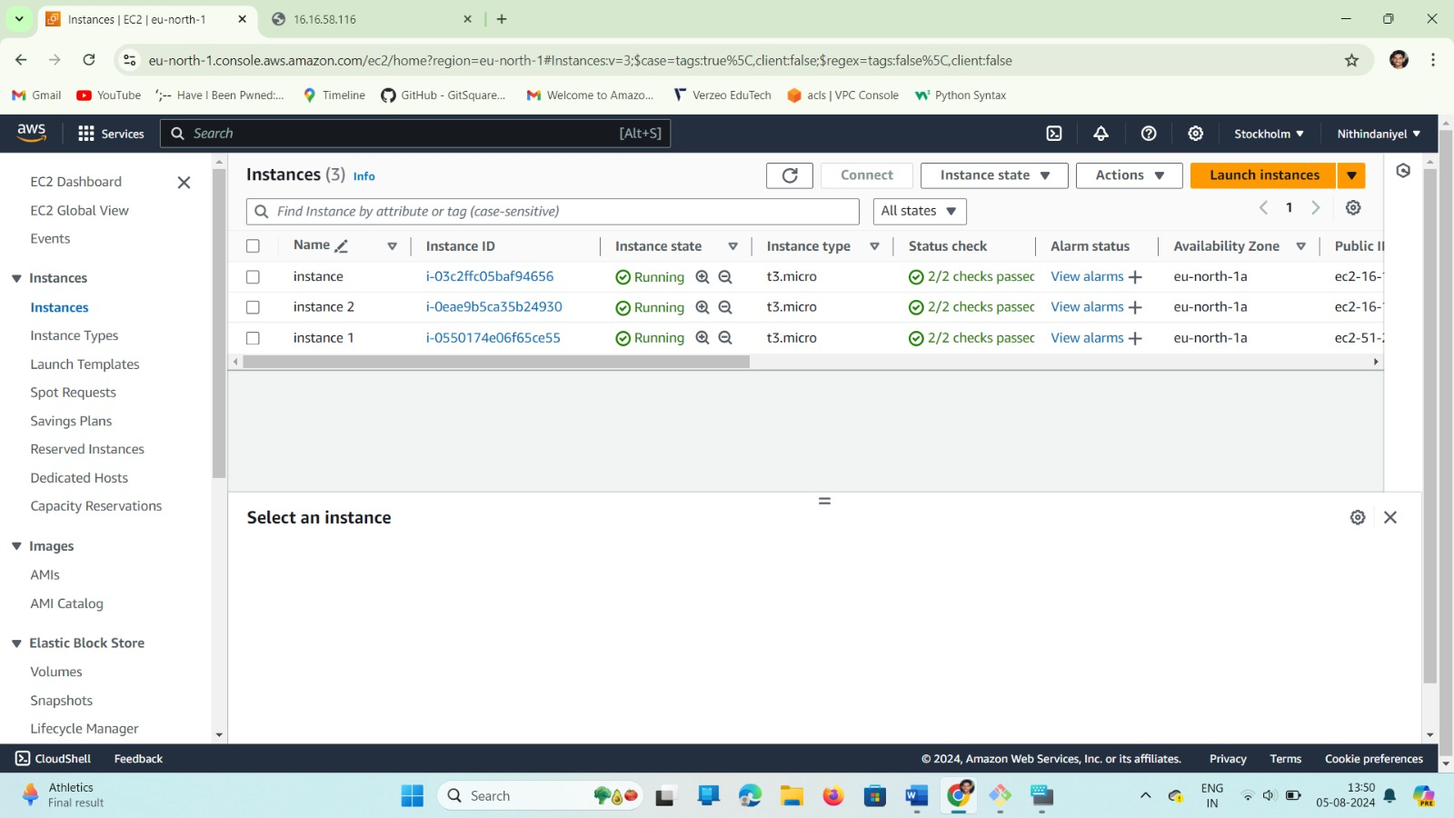

# *Connect to instance one after one.

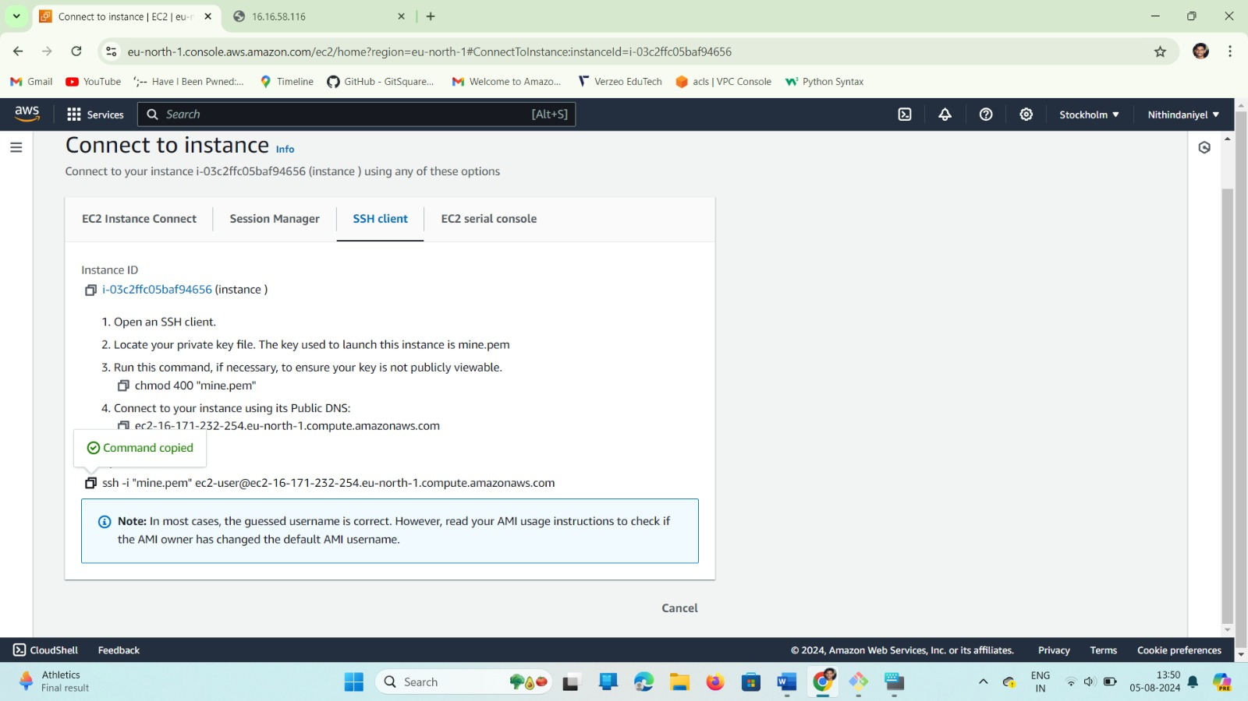

*Open Git Bash and connect to the user then follows as root user with sudo -I command.

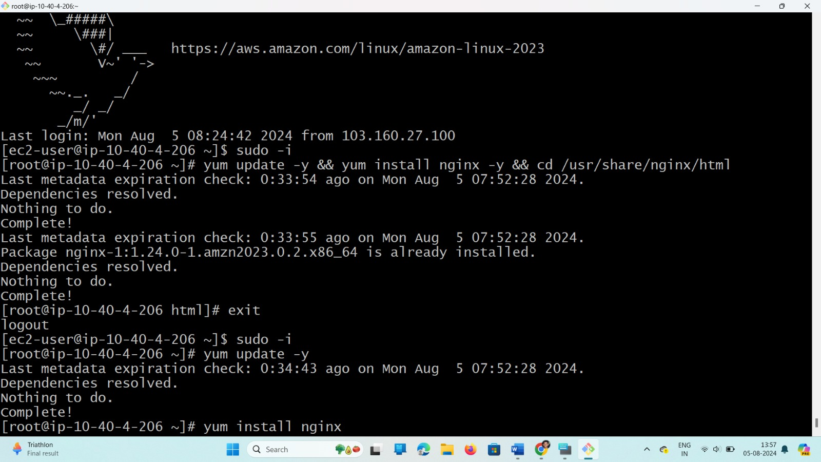

*As above commands do it for another 2 instances.

Output

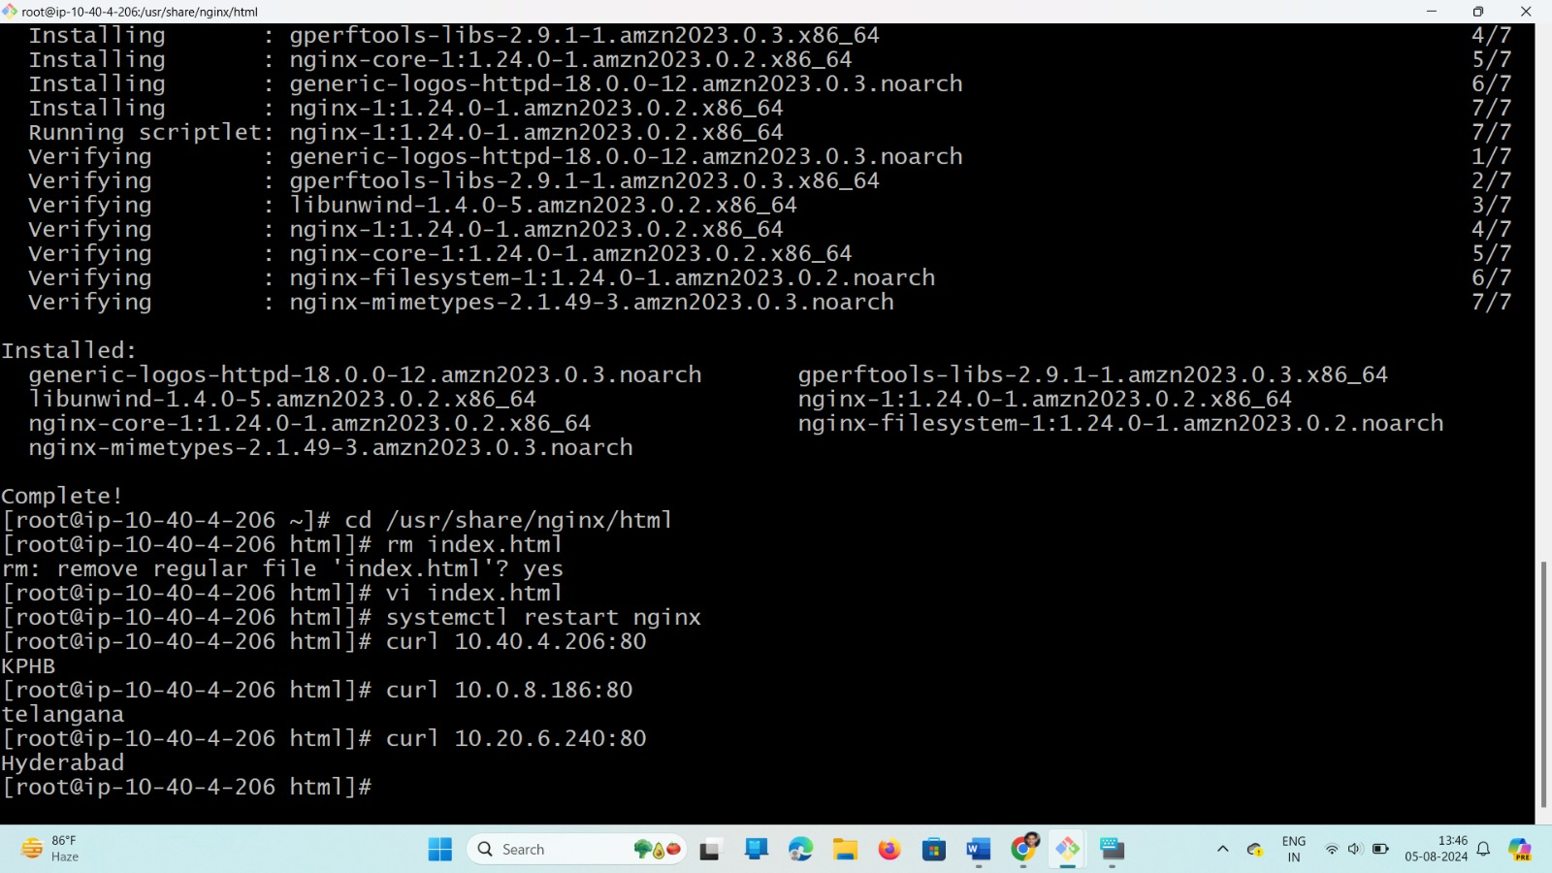

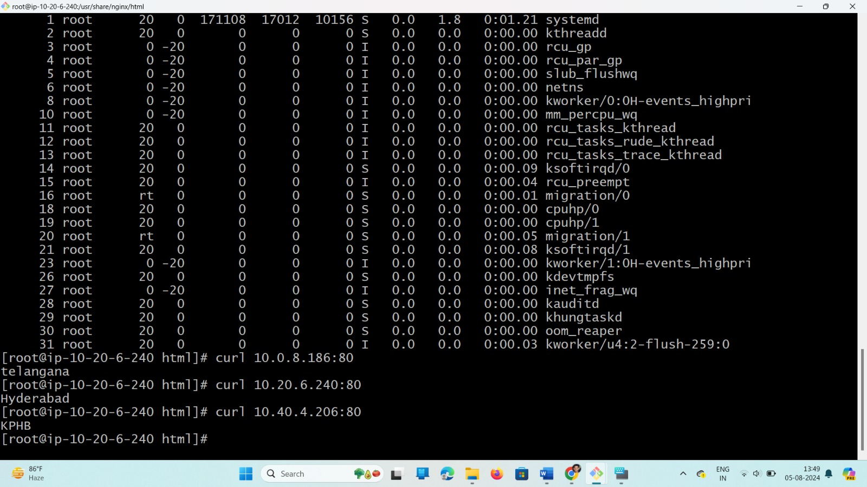

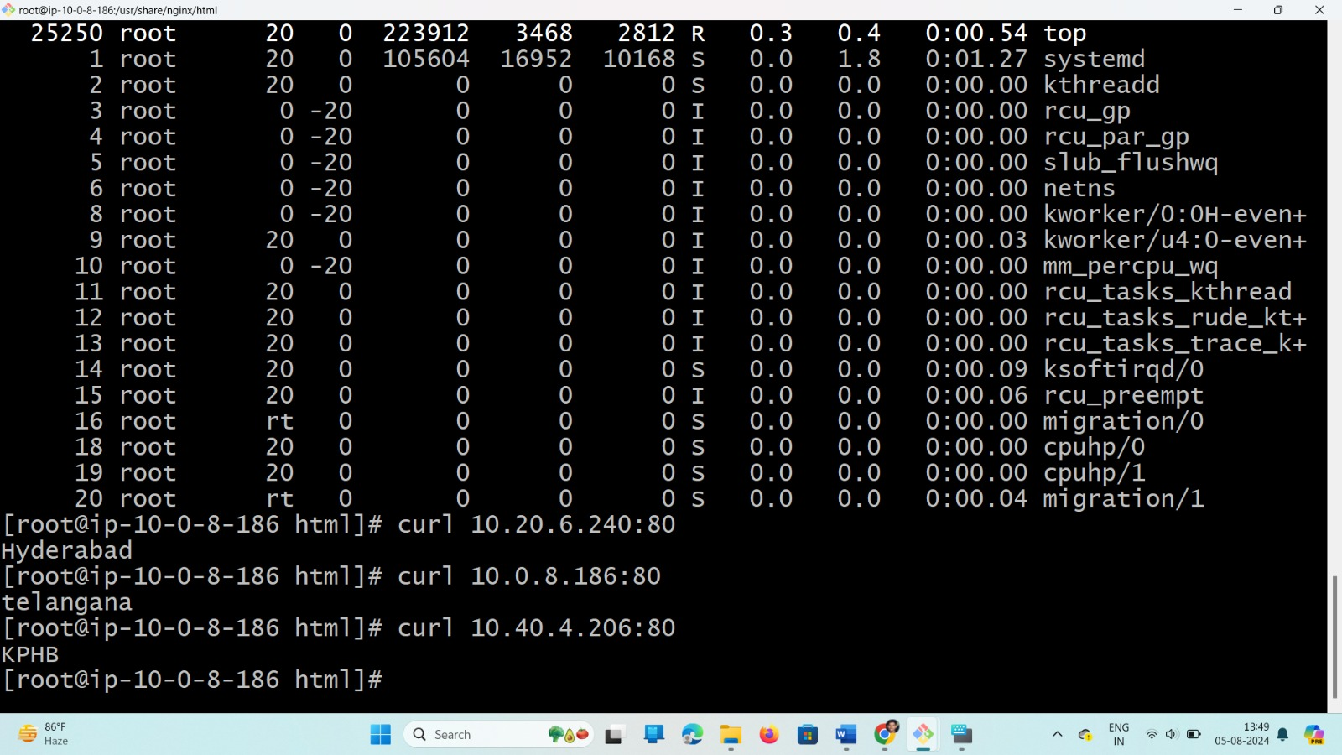

# *Use curl to connect from one VPC to another VPC.

*Like this way connection of 3 VPC’s with Transit Gateway works.